Covid-19 project

***NAME: atef moustafa abdelmenem elnahas***

***B.N****: 1099*

***DATE****: 12/6/2021*

***TOPIC****:covid -19*

|  |  |  |
| --- | --- | --- |
|  |  |  |

# ABSTRACT

Corona virus is one of the most important topics in the world at the present time due to its seriousness and its consequences that cause panic and fear.

# SCREENSHOTS

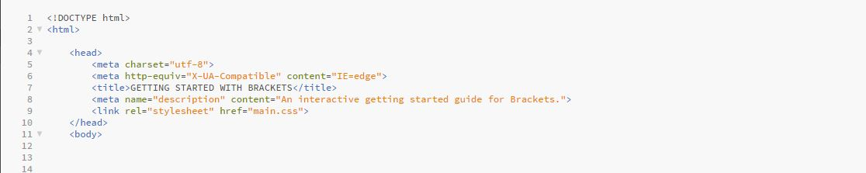

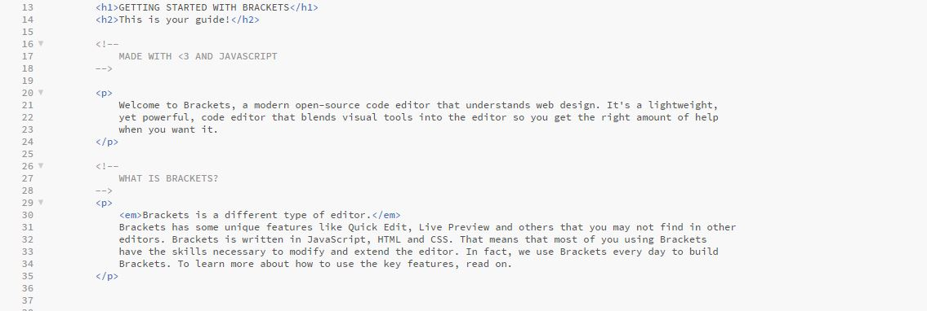

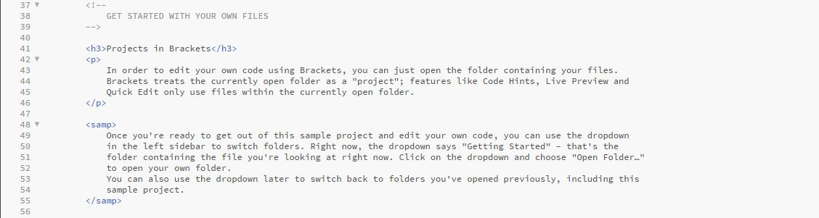

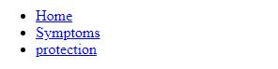

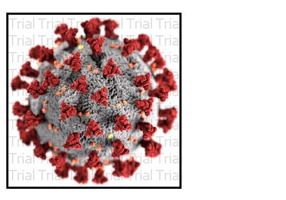

# C:\Users\Shapan PC\Desktop\التاته.JPG